

**BY: NITIN KUMAR VASHISTH**

**XII-‘A’**

**WHAT ARE YOU LOOKING FOR ?**

1. **CERTIFICATE 3**

**2. ACKNOWLEDGEMENT** ***4***

**3. INTRODUCTION** ***5***

**4. SCREEN SHOTS** ***6***

**5. SOURCE CODE**  ***8***

**6. SAMPLE OUTPUT** ***19***

**7. LIMITATION OF THE** ***20***

**PROJECT**

**8. BIBLIOGRAPHY** ***21***

* **NAME~**
* **CLASS~**
* **REGD. NO:**

**Certified that this is a bonafied record of practical work done by _______________in the senior computer science laboratory during the year 2009-10.**

**Submitted to practical examination in the senior computer science laboratory of the school on _____________.**

**Internal Examiner External Examiner**

**ACKNOWLEDGEMENT**

I am grateful to my sister who has helped me out while working on this project. I am grateful to my beloved computer sir, **Mr. A. K Pandey** who has always been guiding us for the success of this project. Thank you to every life and object who or which has contributed for the success of this project.

**INTRODUCTION**

This is a project consists a set of Questions in which the program asks you in a friendly manner.

You can add questions to the bank if you are the administrator. The opening page asks for your way of login, if you login as administrator then it will ask a password. If you want to play the quiz then you must login as guest user and enjoy the quiz game. The program is set to ask how many would you like to play and questions are asked according to that numbers. The program calculates the score and gives comments according to the score. After the games is over it again goes back to the menu.

**SCREEN SHOTS**

1. **THE HOME PAGE**

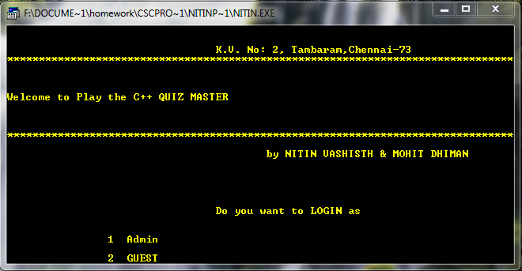

1. **LOGGED IN AS ADMIN**

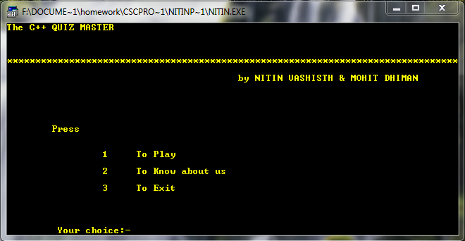

1. **QUESTION BEING ASKED AND ANSWERED**

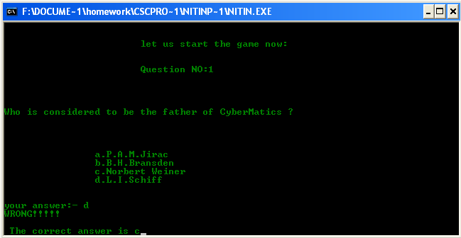

**SOURCE CODE**

#include<iostream.h>

#include<conio.h>

#include<process.h>

#include<stdio.h>

#include<fstream.h>

#include<string.h>

#include<iomanip.h>

#include<bios.h>

#include<dos.h>

#include<stdlib.h>

int points=0;

class quizm

{

char ques[100];

char opta[25];

char optb[25];

char optc[25];

char optd[25];

char answer;

char input;

public:

void menudesign()

{

cout<<endl<<endl<<endl<<endl<<endl<<endl;

cout<<"\t\t\t\t K.V. No: 2, Tambaram,Chennai-73"<<endl;

for(int i=0;i<80;i++)

cout<<"*";

cout<<endl<<endl<<endl;

cout<<"The C++ QUIZ MASTER"<<endl;

cout<<endl<<endl<<endl;

for(i=0;i<80;i++)

cout<<"*";

cout<<endl;

cout<<"\t\t\t\t\t by NITIN VASHISTH & MOHIT DHIMAN";

cout<<endl<<endl<<endl;

cout<<endl<<endl<<endl;

}

void getques();

void display(){

puts(ques);

puts(opta);

puts(optb);

puts(optc);

puts(optd);

cout<<answer;

}

void menu(int *choice,int admin);

void show()

{

cout<<endl<<endl<<endl;

char uans; char b;

puts(ques);

cout<<endl<<endl<<endl;

cout<<"\n\t\t"<<"a."<<opta;

cout<<"\n\t\t"<<"b."<<optb;

cout<<"\n\t\t"<<"c."<<optc;

cout<<"\n\t\t"<<"d."<<optd;

cout<<endl<<endl<<endl;

cout<<"your answer:- ";

cin>>uans;

if(uans==answer)

{

cout<<endl<<"CORRECT !!!";points++;

getch();

clrscr();

}

else

{

cout<<"WRONG!!!!!"<<"\n\n The correct answer is "<<answer<<"\a";

getch();

clrscr();

}

}

};

void quizm::menu(int *choice,int admin)

{

textcolor(GREEN);

cout<<endl<<endl<<endl<<endl<<endl<<endl;

cout<<"\t\t\t\t K.V. No: 2, Tambaram,Chennai-73"<<endl;

for(int i=0;i<80;i++)

cout<<"*";

cout<<endl<<endl<<endl;

cout<<"The C++ QUIZ MASTER"<<endl;

cout<<endl<<endl<<endl;

for(i=0;i<80;i++)

cout<<"*";

cout<<endl;

cout<<"\t\t\t\t\t by NITIN VASHISTH & MOHIT DHIMAN";

cout<<endl<<endl<<endl;cout<<endl<<endl<<endl;

cout<<"\tPress"<<endl<<endl<<endl;

cout<<"\t\t 1 To Play";cout<<endl<<endl;

cout<<"\t\t 2 To Know about us";cout<<endl<<endl;

cout<<"\t\t 3 To Exit\n\n";

if(admin == 1)

cout<<"\t\t 4 Add Question"<<endl;

cout<<endl<<endl<<endl<<"\t Your choice:-";

cin>>*choice;

}

void quizm::getques()

{

fstream f; quizm Q;

textcolor(RED);

f.open("Qbank.dat",ios::app|ios::binary);

cout<<"enter the question"<<endl;

gets(ques);

cout<<"enter the options"<<endl;

gets(opta);

gets(optb);

gets(optc);

gets(optd);

cout<<"correct answr"<<endl;

cin>>answer;

f.write((char*)&Q,sizeof(Q));

f.close();

}

void main()

{

int caseinp,b,noq,ua,pwd,admin;

char ex,cont; char *pswd;

quizm q;

textcolor(YELLOW);

start:

clrscr();

cout<<endl<<endl<<endl<<endl<<endl<<endl;

cout<<"\t\t\t\t K.V. No: 2, Tambaram,Chennai-73"<<endl;

for(int i=0;i<80;i++)

cout<<"*";

cout<<endl<<endl<<endl;

cout<<"Welcome to Play the C++ QUIZ MASTER"<<endl;

cout<<endl<<endl<<endl;

for(i=0;i<80;i++)

cout<<"*";

cout<<endl;

cout<<"\t\t\t\t\t by NITIN VASHISTH & MOHIT DHIMAN";

cout<<endl<<endl<<endl;cout<<endl<<endl<<endl;

cout<<"\t\t\t\t Do you want to LOGIN as \n\n";

cout<<"\n\t\t1 Admin \n\n\t\t2 GUEST";

ua = getch();

if(ua=='1')

{

pswd = getpass("\n\n\t\tEnter the password:");

if(strcmp(pswd,"vashisth") == 0)

admin = 1;

else

{

cout<<"\n\n\t\tInvalid Password!!";

getch();

goto start;

}

}

else

admin = 0;

clrscr();

q.menu(&caseinp,admin);

while(1)

{

switch(caseinp)

{

case 1 :

clrscr();

q.menudesign();

cout<<"\n\tHowmanyquestionswouldyouliketoplay? max(20)"<<endl;

cin>>noq;

clrscr();

fstream f;

f.open("QBANK.dat",ios::binary|ios::in|ios::out);

quizm q;

/*while(!f.eof())

{

f.read((char *)&q,sizeof(q));

q.display();

getch();

clrscr();

} */

for(int k=0;k<noq;k++)

{ q.menudesign();

if(k==0)

cout<<endl<<endl<<"\t\t\t\let us start the game now:\n\n\n";

f.read((char *)&q,sizeof(q));

// f.read((char*)&Q,sizeof(Q));

cout<<"\t\t\tQuestion NO:"<<k+1<<"\n\n";

q.show();

}

cout<<endl<<endl<<endl;

clrscr();

q.menudesign();

if(points==noq)

cout<<"\t\tExcellent \n\n You scored full mounty\t"<<points;

if(noq-points==1)

cout<<"\t\tGood \n\n You are one short of scoring full";

if(noq-points>=2)

cout<<"\t\tYou scored \n\n\t\t"<<points<<" out of "<<noq;

getch();

clrscr();

q.menu(&caseinp,admin);

break;

case 2 :

textcolor(CYAN);

clrscr();

cout<<endl<<endl<<endl;

cout<<endl<<endl<<endl;

cout<<"\t\t\t\t K.V. No: 2, Tambaram,Chennai-73";cout<<endl;

for(int i=0;i<80;i++)

cout<<"*"; cout<<endl<<endl<<endl;

cout<<"The C++ QUIZ MASTER"<<endl;

cout<<endl<<endl<<endl;

for(i=0;i<80;i++)

cout<<"*";

cout<<endl;

cout<<endl<<endl;

cout<<"\t This a creation for School Cbse project(computer science) year 2003-10"<<endl;cout<<endl<<endl;

cout<<"The members of the project are :";

cout<<endl<<endl;

cout<<"NITIN VASHISTH XII Science"<<endl;

cout<<endl<<endl;

cout<<"MOHIT DHIMAN XII Sceince"<<endl<<endl;

cout<<endl<<endl;

cout<<"SUBJECT TEACHER : \t A.K PANDEY";

getch();

clrscr();

q.menu(&caseinp,admin);

break;

case 3 :

clrscr();

q.menudesign();

cout<<"\n\n\n\n\t\t\tAre you sure ?\n Press y/n";

ex=getch();

if(ex=='y')

{

clrscr();

exit(3);

}

else

{

clrscr();

q.menu(&caseinp,admin);

}

case 4 :

clrscr();

q.menudesign();

q.getques();

cout<<"Do you want to add another question:";

pwd = getchar();

if(pwd == 'y' || pwd == 'Y')

{

clrscr();

caseinp = 4;

}

else

{ clrscr();

q.menu(&caseinp,admin);

}

break;

default :

cout<<" wrong input ";

}

}

}

Sample OUTPUT

Do you want to LOGIN as

1. Admin
2. GUEST

ENTERED-: 2

Press

1. To Play
2. To Know about us
3. To Exit
4. Your choice:- 1

How many questions would you like to play? max(20)

1

let us start the game now:

Question NO:1

Who is considered to be the father of CyberMatics ?

a.P.A.M.Jirac

b.B.H.Bransden

c.Norbert Weiner

d.L.I.Schiff

your answer:- c

CORRECT !!!!!

Excellent

You scored full mounty 1

LIMITATIONS OF THE SUCCESSFUL PROJECT

* This project does not contain graphics which is popular in the present world.
* There are only 20 questions which are preloaded.
* The order of the questions has been fixed. NO use of random function.

BIBLIOGRAPHY

* **COMPUTER SCIENCE TEXT BOOK BY SUMITA ARORA.**
* **PICASA 3 for SCREENSOTS**

* **BRITANICA QUIZ MASTER FOR QUESTIONS**
* **SNIPPING TOOL FOR CUTTING**